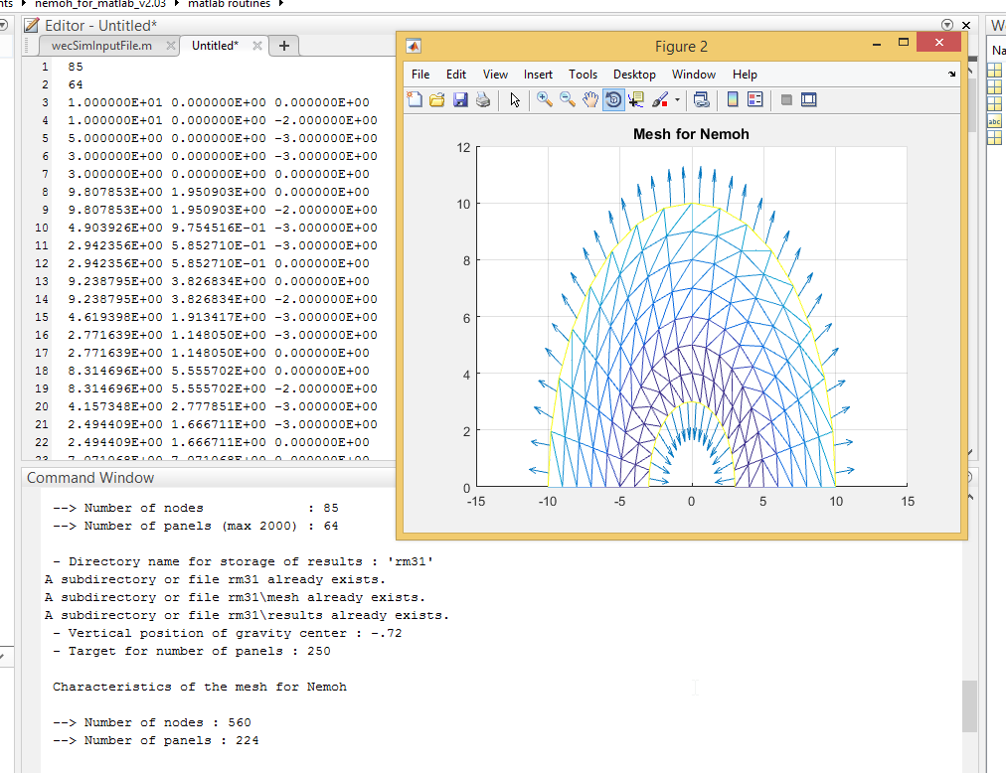

Below are images of the generated mesh using the aximesh MATLAB routine for the RM3 float to be used in NEMOH.

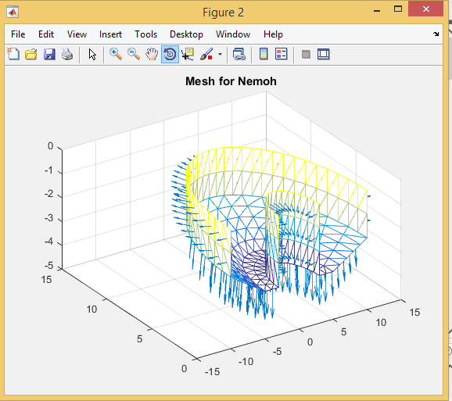

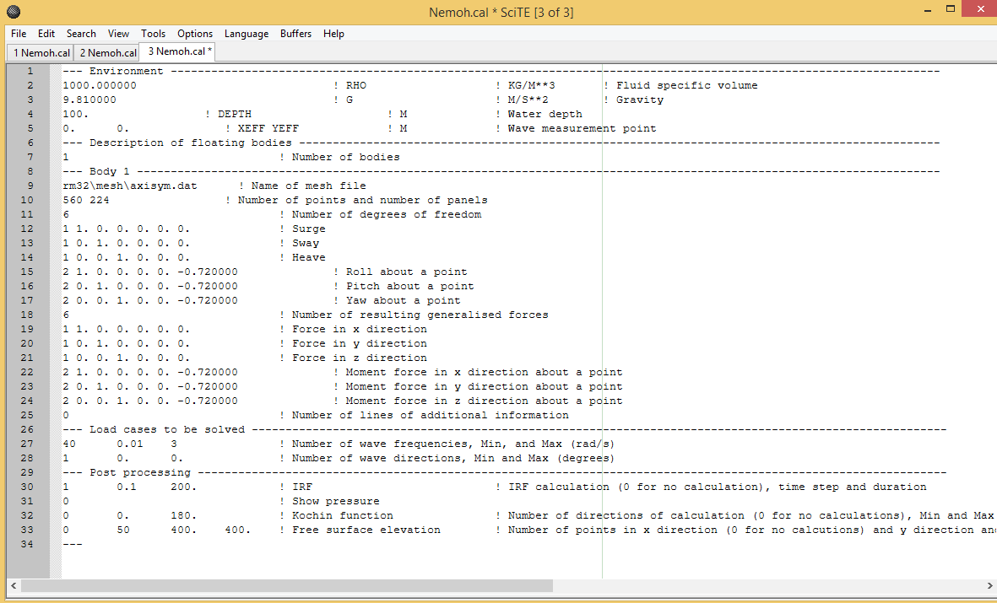
After running NEMOH, the nemoh.cal file has three dashes at the end shown above that need to be removed to run in BEMIO and ensure there are only 34 lines after removing the dashes, modification shown below

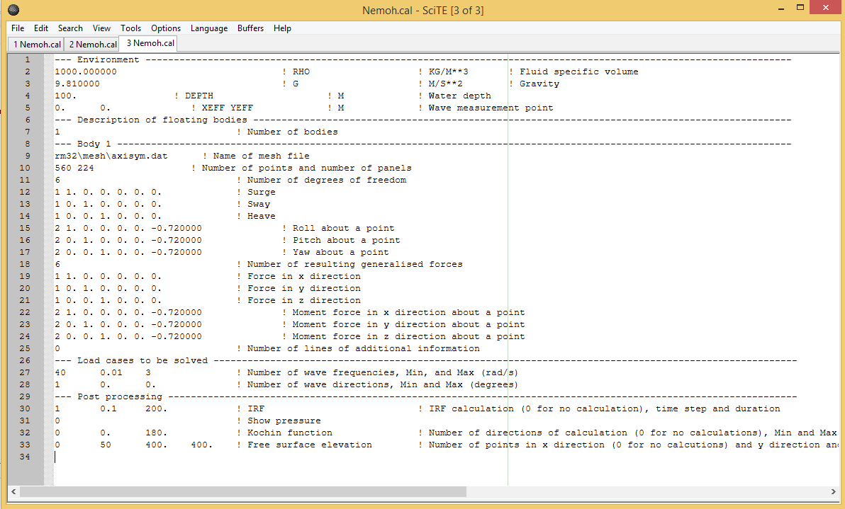

Below are output comparisons of WECSIM using NEMOH generated files on the left and the RM3 WAMIT based tutorial file for buoy “A” (the float of the RM3 device). As far as I could tell they looked the same for the damping value used. I did not graph the outputs to compare on the same graph at this time.

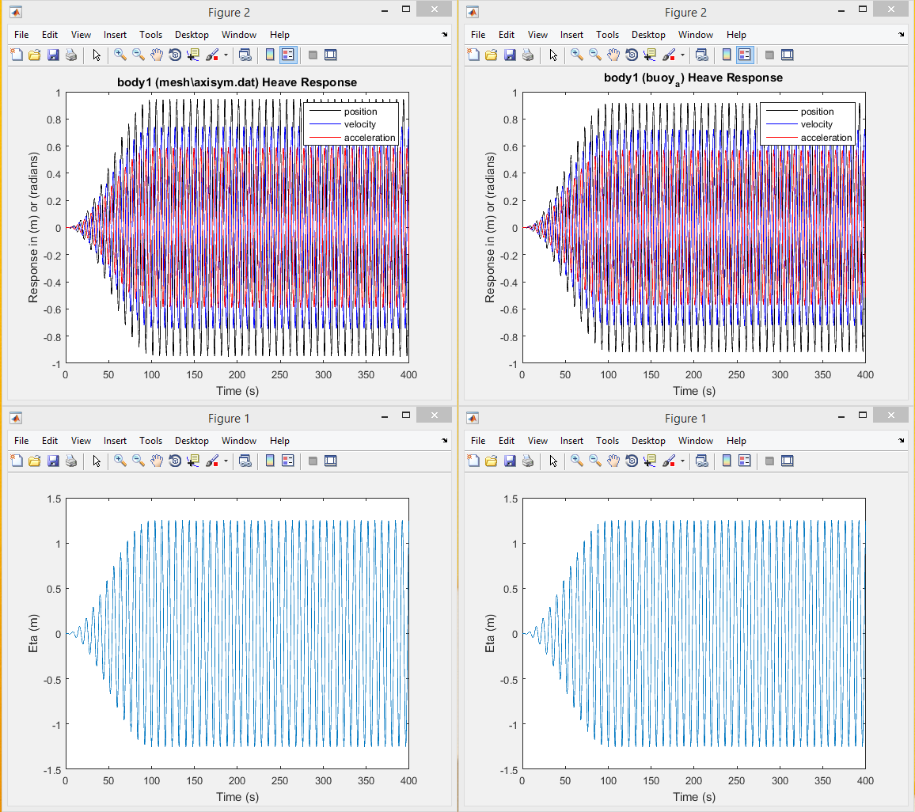

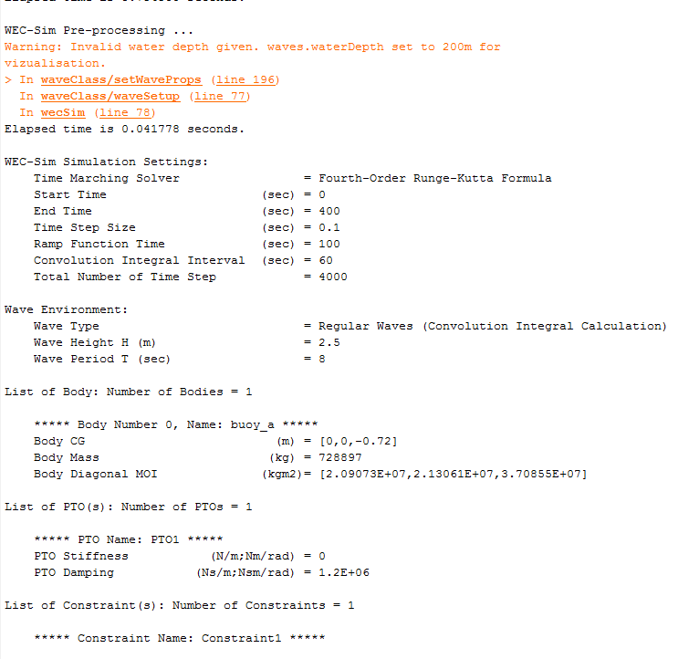

Above shows some WECSIM outputs using the WAMIT generated files at the top, showing an equilibrium body mass of 728897 KG. Below shows some WECSIM outputs using the NEMOH generated files, showing an equilibrium body mass of 722094KG. I am thinking the differences here could be in how fine the mesh is in either program.
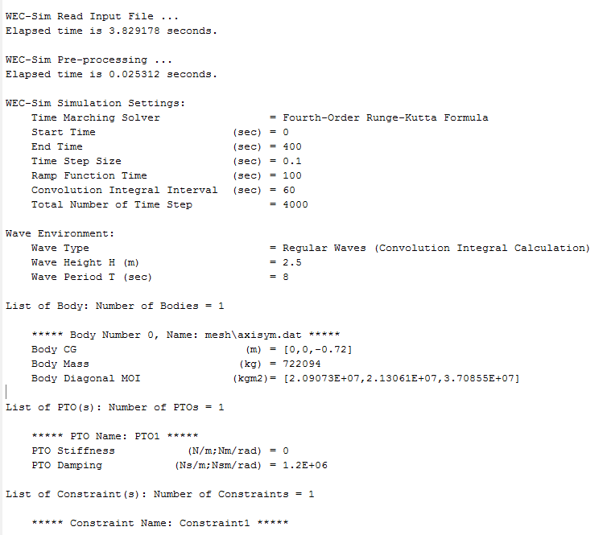

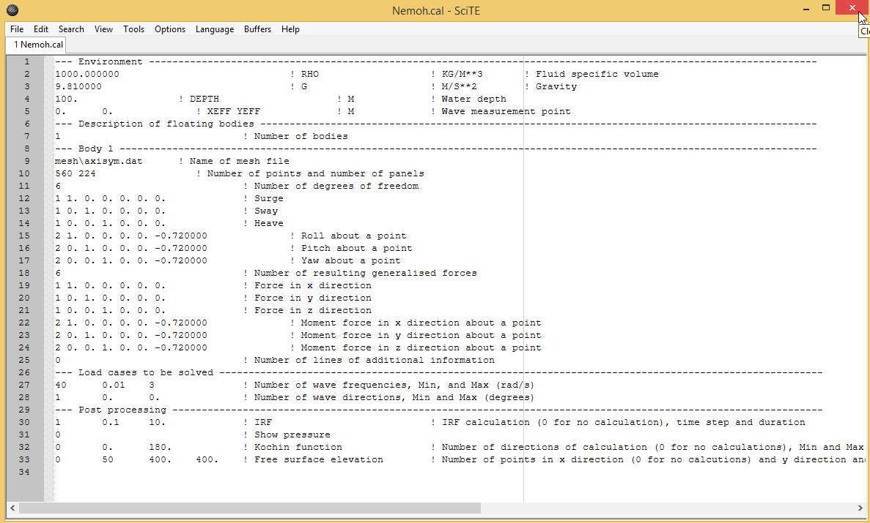

Above is an example NEMOH file I ran of one of our device's files when I was trying to generate issues in WEC-SIM. The resulting error in WECSIM is below, with the IRF time being to short. Default CIC time is 60 seconds, and the above nemoh.cal file only has a duration of 10 seconds with a 0.1 second time step.

